Regression For Machine Learning
Introduction to Regression
Regression is a supervised learning technique used to model the relationship between a dependent variable (target) and one or more independent variables (features). It is primarily used for predicting continuous values, such as house prices, stock prices, or temperature. Regression analysis helps us understand how the value of the dependent variable changes when one or more independent variables are varied.
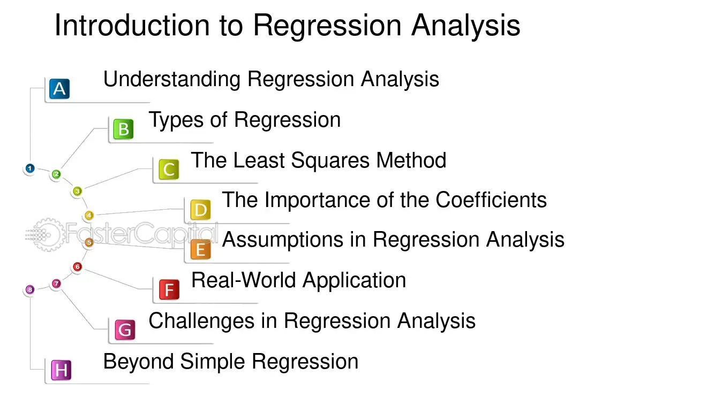
Mathematics Involved in Regression
The core idea of regression is to find the best-fitting line or curve that minimizes the difference between the predicted and actual values. This is achieved by optimizing a loss function, typically the Mean Squared Error (MSE).
Key Mathematical Concepts:
- Linear Relationship:
  - In simple linear regression, the relationship between the dependent variable Y and the independent variable X is modeled as:
Y=β0​+β1​X+ϵ
- Y: Dependent variable (target).
- X: Independent variable (feature).
- β0​: Intercept (value of Y when X=0).
- β1​: Slope (change in Y for a unit change in X).
- ϵ: Error term (difference between the predicted and actual value).
Multiple Linear Relationship:
- When there are multiple independent variables, the relationship is modeled as:
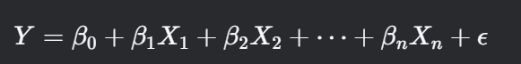
Loss Function (Mean Squared Error - MSE):
- The goal is to minimize the MSE, which measures the average squared difference between the predicted and actual values:
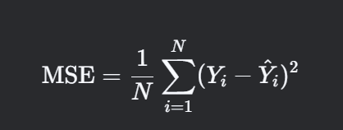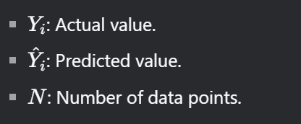
- Optimization:
  - The parameters (β0,β1​,…,βn​) are estimated using optimization techniques like:
    - Ordinary Least Squares (OLS): Minimizes the sum of squared residuals.
    - Gradient Descent: Iteratively adjusts the parameters to minimize the loss function.

Regression Algorithms
1. Simple Linear Regression
- Definition: Models the relationship between a single independent variable XX and a dependent variable Y using a straight line.
- Equation:
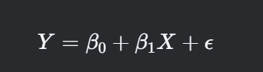
- Use Case: Predicting house prices based on square footage.

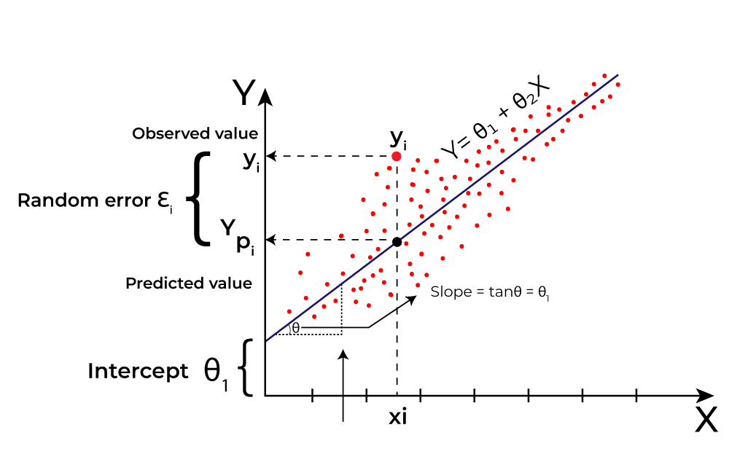
2. Multiple Linear Regression
- Definition: Extends simple linear regression to model the relationship between multiple independent variables X1,X2,…,Xn and a dependent variable Y.
- Equation:
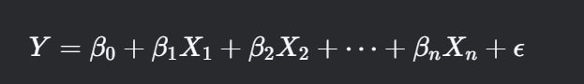
- Use Case: Predicting house prices based on square footage, number of bedrooms, and location.
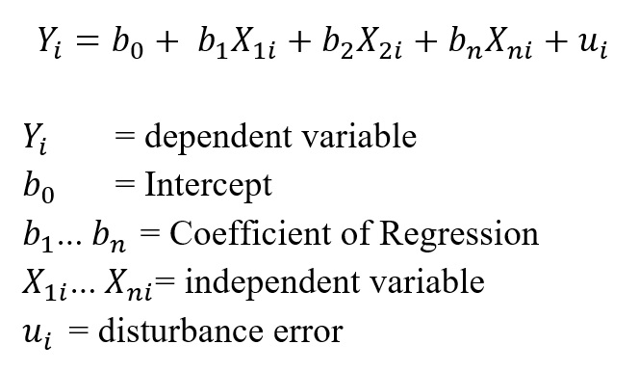

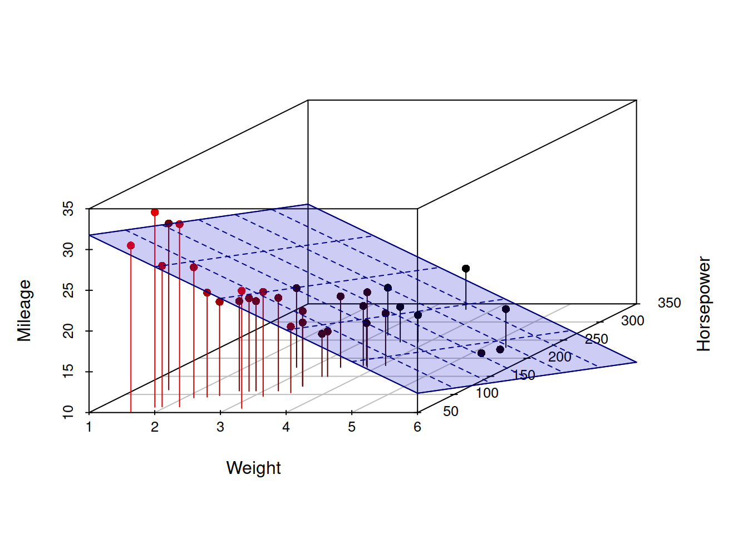
3. Polynomial Regression
- Definition: Models the relationship between X and Y as an n-degree polynomial. It is useful when the relationship is non-linear.
- Equation:
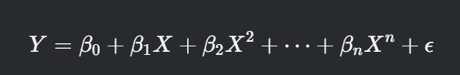
- Use Case: Modeling the growth rate of plants over time.
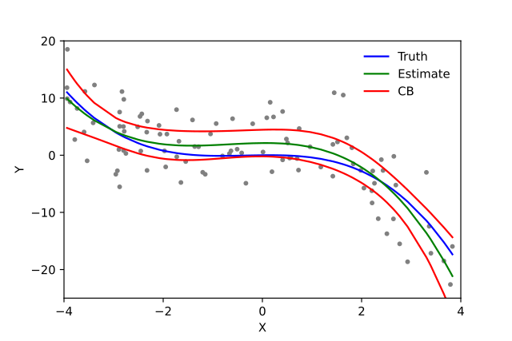
4. Lasso Regression (L1 Regularization)
- Definition: Adds an L1 penalty term 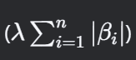 to the loss function to shrink less important feature coefficients to zero, effectively performing feature selection.
- Equation:
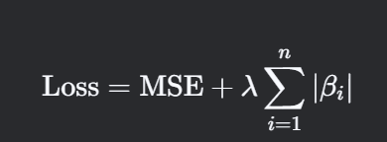
- Use Case: When you have many features and want to perform feature selection.

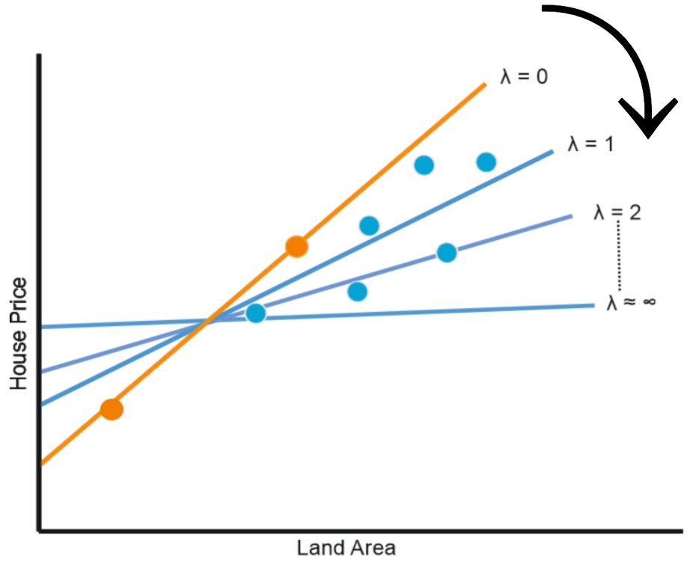
5. Ridge Regression (L2 Regularization)
- Definition: Adds an L2 penalty term 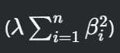 o the loss function to shrink the coefficients, reducing model complexity and preventing overfitting.
- Equation:
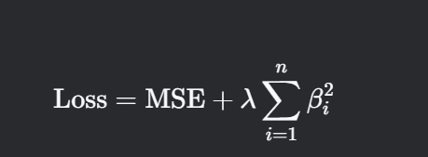
- Use Case: When you have multicollinearity (high correlation among features).
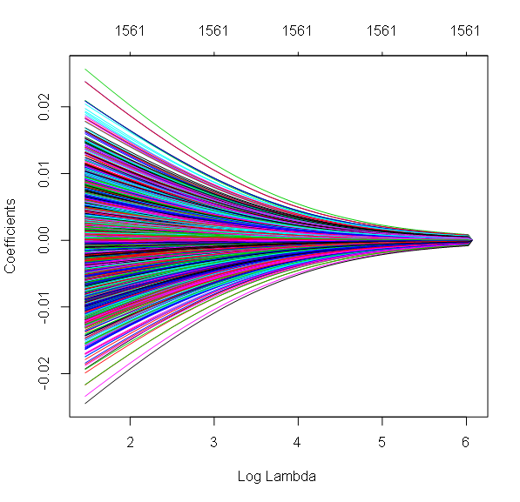
6. Elastic Net Regression
- Definition: Combines L1 and L2 regularization to balance feature selection and coefficient shrinkage.
- Equation: 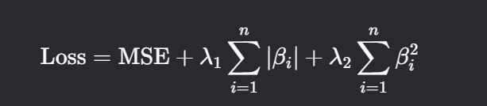
- Use Case: When you have many features and want to balance between Lasso and Ridge.
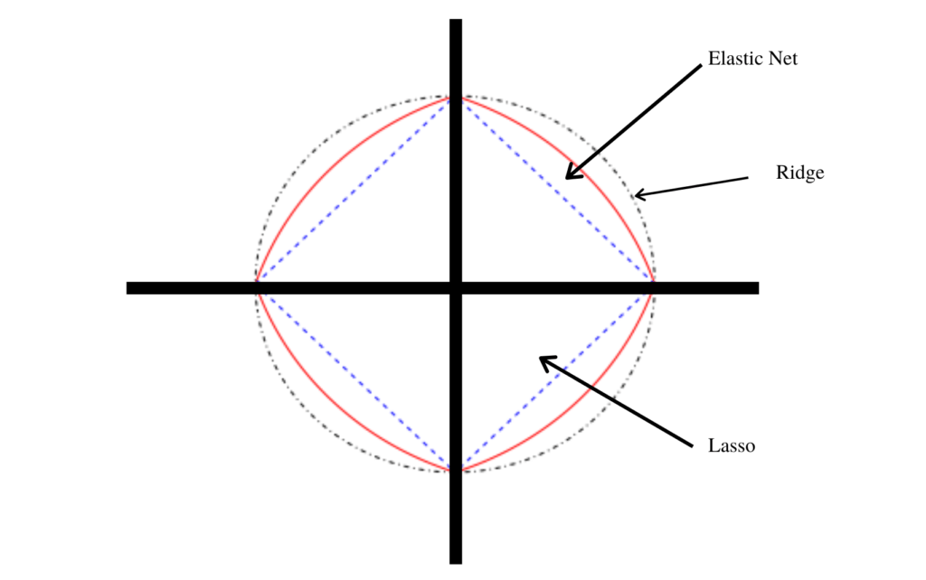

Key Differences Between Regression Algorithms
Algorithm | Key Feature | Use Case
Simple Linear Regression | Models a linear relationship between one independent variable and the target. | Predicting house prices based on square footage.
Multiple Linear Regression | Models a linear relationship between multiple independent variables and the target. | Predicting house prices based on square footage, bedrooms, and location.
Polynomial Regression | Models non-linear relationships using polynomial terms. | Modeling growth rates or curved relationships.
Lasso Regression | Performs feature selection by shrinking less important coefficients to zero. | When you have many features and want to select the most important ones.
Ridge Regression | Reduces overfitting by shrinking all coefficients. | When you have multicollinearity among features.
Elastic Net Regression | Combines L1 and L2 regularization for a balanced approach. | When you want to balance feature selection and coefficient shrinkage.

Steps to Perform Regression Analysis
- Data Collection:
  - Gather the dataset containing the dependent and independent variables.
- Data Preprocessing:
  - Handle missing values, outliers, and categorical variables.
  - Normalize or standardize the features if necessary.

- Model Selection:
  - Choose the appropriate regression algorithm based on the problem and data.
- Model Training:
  - Split the data into training and testing sets.
  - Train the model on the training set.
- Model Evaluation:
  - Evaluate the model using metrics like:
    - Mean Squared Error (MSE)
    - R-squared (Coefficient of Determination)
    - Mean Absolute Error (MAE)
- Model Tuning:
  - Adjust hyperparameters (e.g., regularization strength) to improve performance.
- Prediction:
  - Use the trained model to make predictions on new data.

Interview Questions on Regression Evaluation Metrics
1. Mean Absolute Error (MAE)
🔹 Question: What is Mean Absolute Error (MAE), and how is it calculated?
🔹 Answer: MAE is the average absolute difference between actual and predicted values.
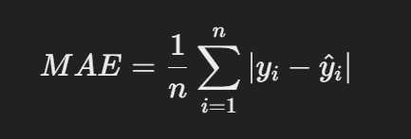

✔ It measures how close predictions are to actual values, with lower values indicating better performance.
🔹 Question: When would you prefer MAE over other metrics?
🔹 Answer: When outliers are present, because MAE treats all errors equally without squaring.

2. Mean Squared Error (MSE)
🔹 Question: What is Mean Squared Error (MSE), and why do we square the errors?
🔹 Answer: MSE is the average of squared differences between actual and predicted values.
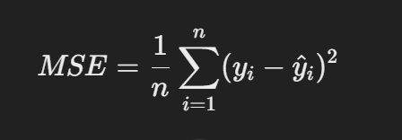

✔ Squaring ensures larger errors get more weight, penalizing large deviations more.
🔹 Question: What is the major drawback of MSE?
🔹 Answer: It squares errors, making it sensitive to outliers.

3. Root Mean Squared Error (RMSE)
🔹 Question: What is RMSE, and why do we take the square root of MSE?
🔹 Answer: RMSE is the square root of MSE, bringing the error back to the original units.


✔ Helps in interpreting error in the same scale as the target variable.
🔹 Question: When should RMSE be used?
🔹 Answer: When large errors need to be penalized but still want the error in the same unit.

4. R² (Coefficient of Determination)
🔹 Question: What is R², and what does it measure?
🔹 Answer: R² indicates the proportion of variance in the target variable explained by the model.
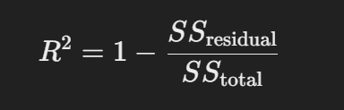
✔ Ranges from 0 to 1, with 1 being a perfect model.
🔹 Question: What does a negative R² value indicate?
🔹 Answer: The model performs worse than a simple mean predictor.

5. Adjusted R²
🔹 Question: Why do we use Adjusted R² instead of R²?
🔹 Answer: Adjusted R² penalizes adding useless variables that don't improve the model.
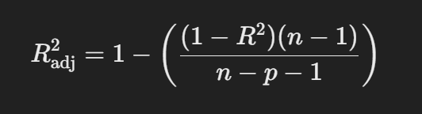
✔ n = Number of observations, p = Number of predictors
🔹 Question: If we add more variables, will R² always increase?
🔹 Answer: Yes, but Adjusted R² only increases if the new feature improves the model.

6. General Questions
🔹 Question: Which metric should be used when outliers are present?
🔹 Answer: MAE or Adjusted R², because MSE and RMSE are sensitive to outliers.
🔹 Question: How do you decide between RMSE and MSE?
🔹 Answer:
- Use MSE when emphasizing large errors.
- Use RMSE when needing an error measure in the same unit as the target.

Important Blogs and Kaggle Links for Regression Evaluation Metrics
📚 Blogs
1️ Understanding Evaluation Metrics for Regression
🔗 https://machinelearningmastery.com/regression-metrics-for-machine-learning/
2️ Regression Metrics Explained (Scikit-Learn Guide)
🔗 https://scikit-learn.org/stable/modules/model_evaluation.html#regression-metrics
3️ Metrics for Regression: MAE, MSE, RMSE, R², Adjusted R²
🔗 https://towardsdatascience.com/metrics-to-evaluate-your-regression-models-6fcdba60068e

📊 Kaggle Links (Practice & Datasets)
1️ Kaggle Notebook on Regression Metrics
🔗 https://www.kaggle.com/code/andonians/linear-regression-example/notebook
2️ Regression Model Performance Evaluation (Kaggle Notebook)
🔗 https://www.kaggle.com/code/kanncaa1/machine-learning-tutorial-for-beginners
3️ Kaggle Dataset: House Price Prediction (Regression Task)
🔗 https://www.kaggle.com/c/house-prices-advanced-regression-techniques

